**1. Display the date using ‘date’ command.**

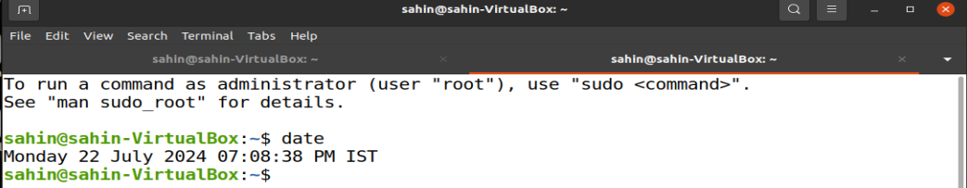

**2. Check who are the users logged in using the ‘who’ command.**

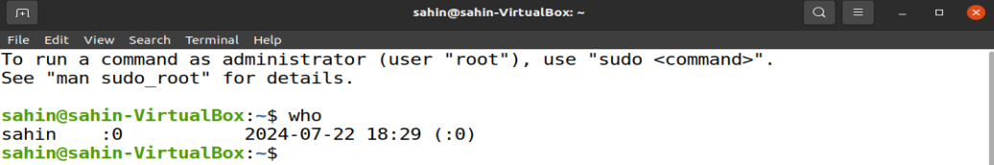

**3. Check the running processes using the ‘ps’ command.**

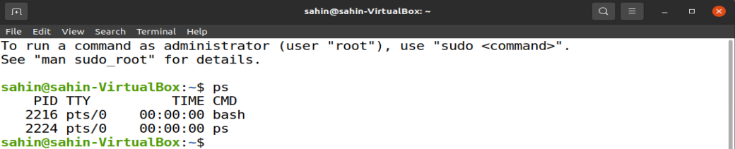

**4. List the files with ‘ls’ command with and without –l option.**

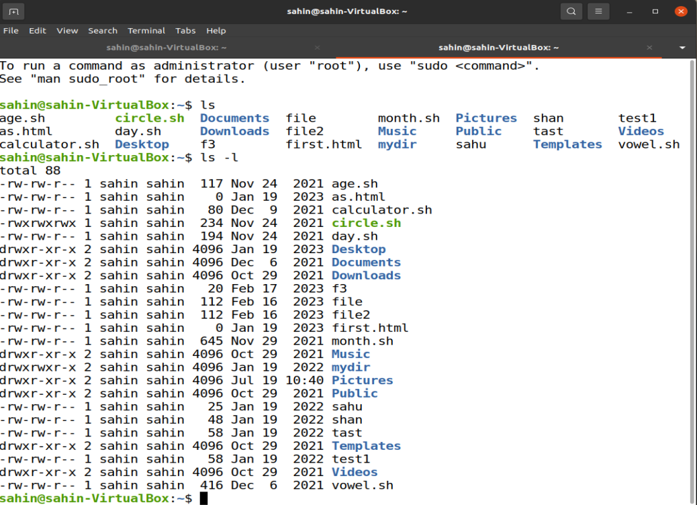

**5. Check the manual of ‘ls’ command.**

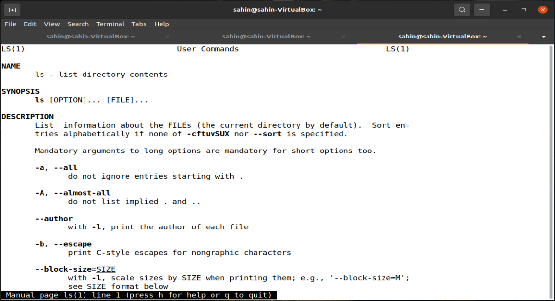

**6. Show the command used to display (i) filenames (ii) processes (iii) users.**







**7. Check and state the difference between man and whats command by checking man cp & whatis cp**

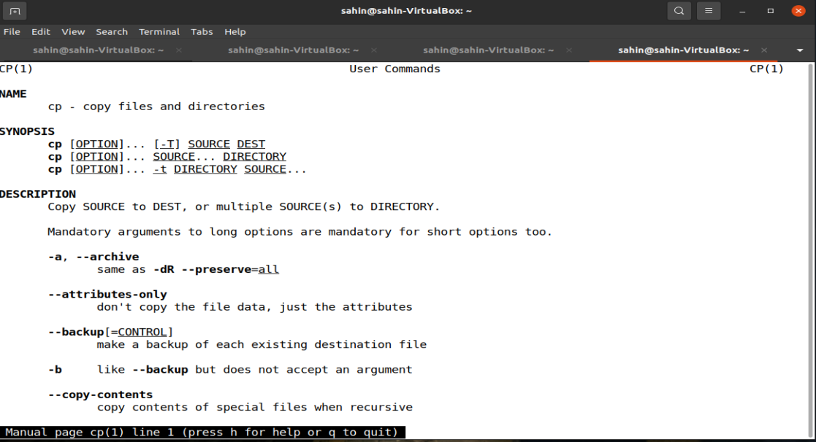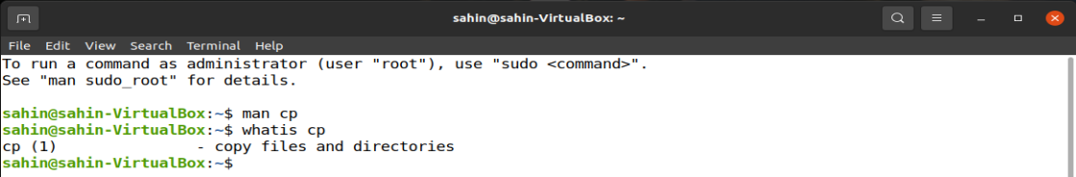

**8. What is primary difference between printf and echo command. Check and print.**

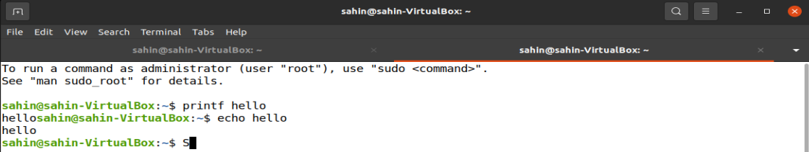

**9. In the home directory, create a directory MCA2022 inside the MCA2022, create another directory <FirstName_Section_ClassRoll> and get into the directory [-/MCA2022/Ankur_A_00$].**

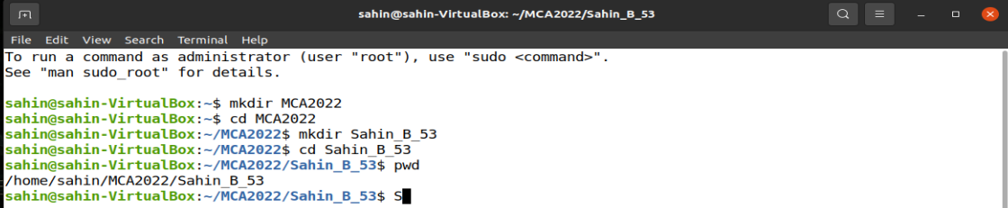

**10. Go to the subdirectory and create another subdirectory ‘Unix_File_System’ within it.**

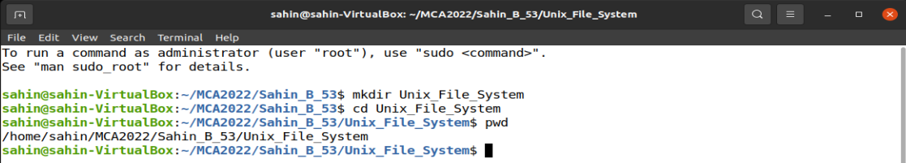

**11. Create the subdirectories TestA,TestB,TestC and corresponding sub-directories TestA-1,TestA-2, TestB-1,TestB-2, TestC-1,TestB-2-i in a single command.**

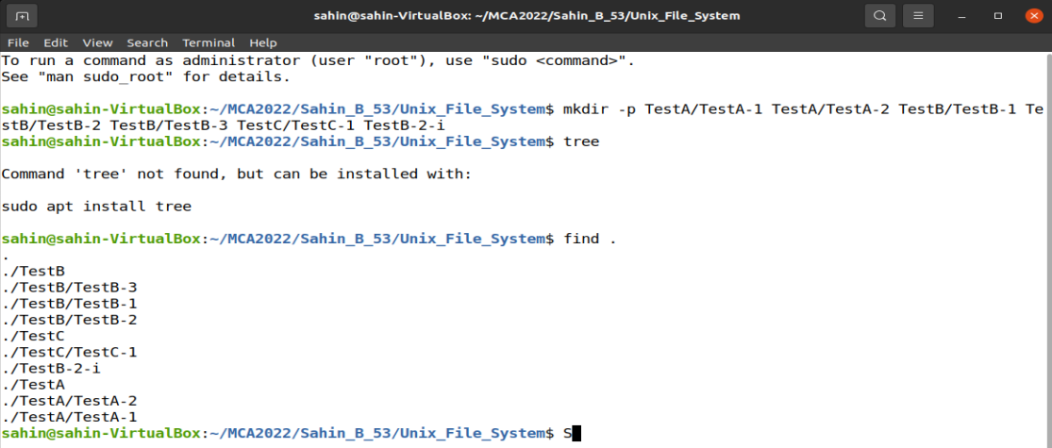

**12. Show the absolute path of TestB-2-i.**

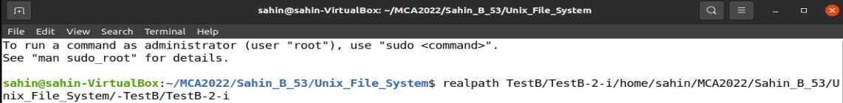

**ASSIGNMENT-2**

**1. Create two C files to print “Hello World!” in two different ways:**

**a. Program containing normal statement terminator → HelloWorld1.c.**

**b. Program without any statement terminator → HelloWorld2.c.**

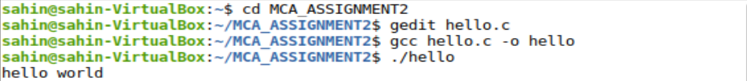

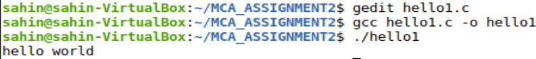

**2. Display the contents of the files.**

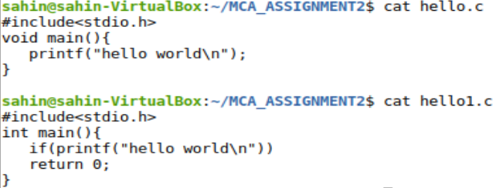

**3. Concatenate the two files to a third file.**



**4. Show the above file types.**

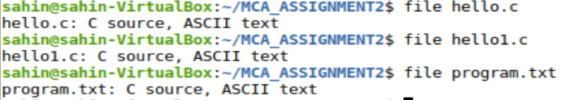

**5. Copy all the files to the home directory in an interactive manner.**

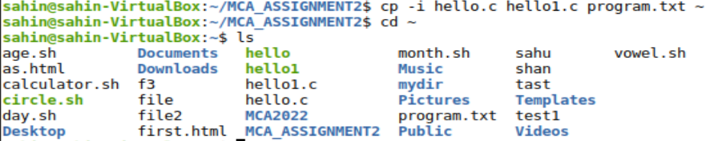

**6. Create a copy of the C file in TestA-1.**



**7. Copy the file to the home directory in an interactive manner.**

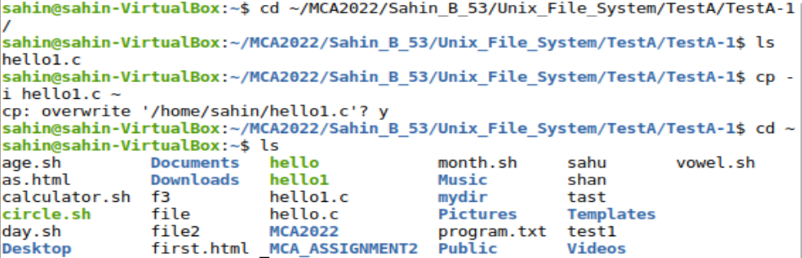

**8. Remove the directories TestC & TestC-1.**

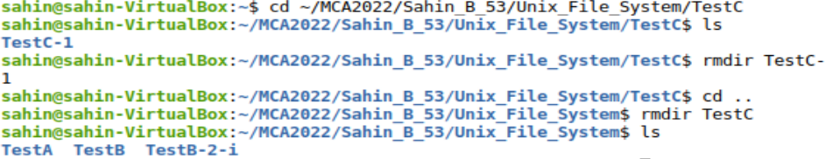

**9. Delete the file C file from TestA-1.**

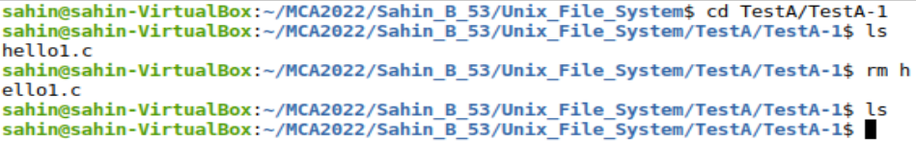

**10. Rename the text file in the home directory.**

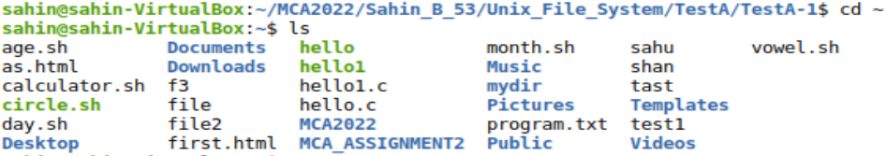

**11. Rename the text file in the home directory.**

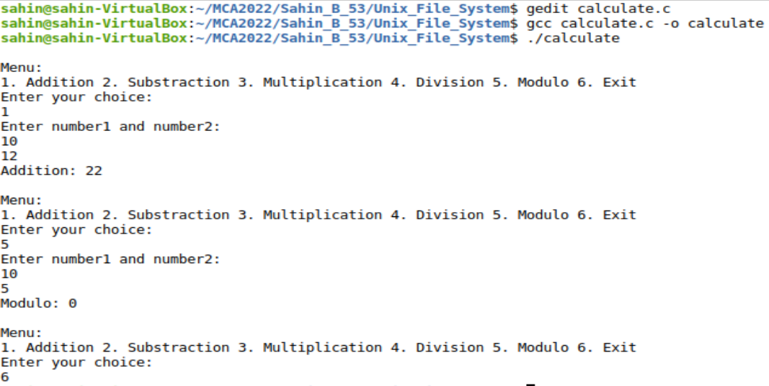

**12. Show the C file in the paged manner using more and less commands.**

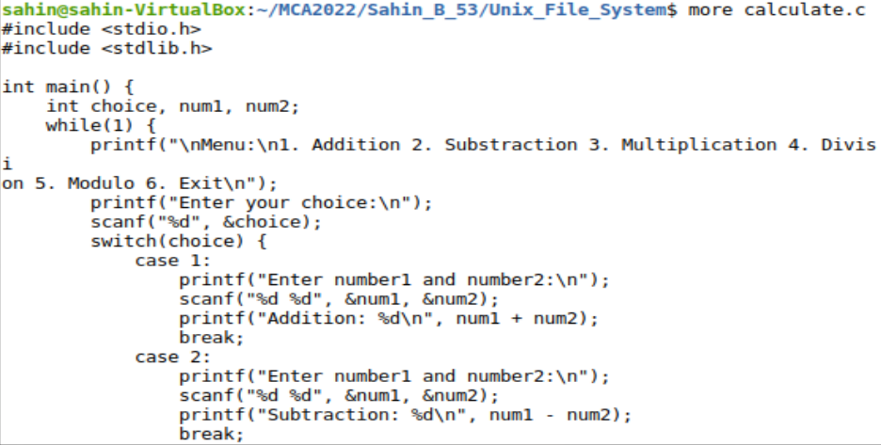

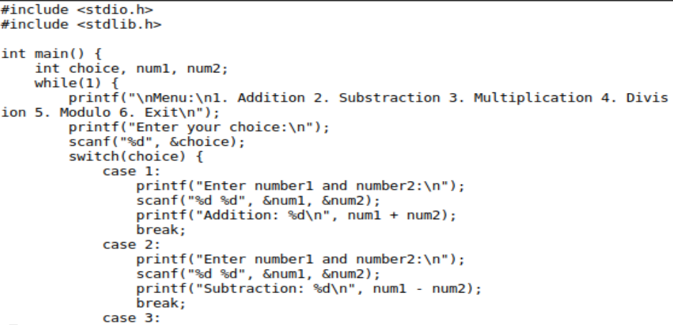

**13. Count the number of lines, words and characters separately.**



**14. Compare the two C files.**

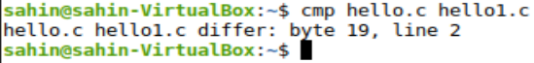

**15. Find what is common in two C files.**

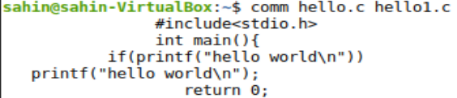

**16. Find the difference in two C files.**

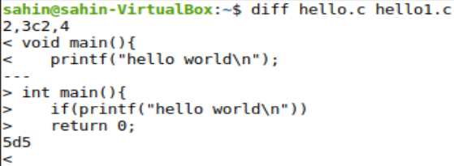

**ASSIGNMENT-3**

**1. Write a C programme to simulate the following non-preemptive CPU scheduling algorithms to find the turnaround time and waiting time for the above problem. A. FCFS B. SJF C. Priority**

**A. FCFS cpu scheduling algorithm.. a. For the FCFS scheduling algorithm, read the number of processes/jobs in the system, and their CPU burst times.**  **b. The scheduling is performed based on the arrival time of the processes, irrespective of their other parameters. c. Each process will be executed according to its arrival time. . d. Each process will be executed according to its arrival time.**

**B. SJF cpu scheduling algorithm.. a. For the SJF scheduling algorithm, read the number of processes/jobs in the system, and their CPU burst times**.  **b. Arrange all the jobs in order with respect to their burst times. c. Two jobs may be in queue with the same execution time, and then the FCFS approach will be performed. d. Each process will be executed according to the length of its burst time.**

**e. Then calculate each process's waiting time and turnaround time accordingly.**

**C. PRIORITY cpu scheduling algorithm.. a. For the priority scheduling algorithm, read the number of processes/jobs in the system, their CPU burst times, and the priorities.**  **b. Arrange all the jobs in order with respect to their priorities. c. There may be two jobs in queue with the same priority, and then FCFS approach will be performed.**  **d. Each process will be executed according to its priority. e. Calculate the waiting time and turnaround time of each of the processes accordingly.**

#include <stdio.h>

struct Process {

int id;

int burst_time;

int arrival_time;

int priority;

int waiting_time;

int turnaround_time; };

void sortByArrivalTime(struct Process proc[], int n) {

for (int i = 0; i < n - 1; i++) {

for (int j = 0; j < n - i - 1; j++) {

if (proc[j].arrival_time > proc[j + 1].arrival_time) {

struct Process temp = proc[j];

proc[j] = proc[j + 1];

proc[j + 1] = temp; }}}}

void sortByBurstTime(struct Process proc[], int n) {

for (int i = 0; i < n - 1; i++) {

for (int j = 0; j < n - i - 1; j++) {

if (proc[j].burst_time > proc[j + 1].burst_time) {

struct Process temp = proc[j];

proc[j] = proc[j + 1];

proc[j + 1] = temp;}}}}

void sortByPriority(struct Process proc[], int n) {

for (int i = 0; i < n - 1; i++) {

for (int j = 0; j < n - i - 1; j++) {

if (proc[j].priority > proc[j + 1].priority) {

struct Process temp = proc[j];

proc[j] = proc[j + 1];

proc[j + 1] = temp; }}}}

void calculateTimes(struct Process proc[], int n) {

int total_waiting_time = 0, total_turnaround_time = 0;

proc[0].waiting_time = 0;

for (int i = 1; i < n; i++) {

proc[i].waiting_time = proc[i - 1].waiting_time + proc[i - 1].burst_time; }

for (int i = 0; i < n; i++) {

proc[i].turnaround_time = proc[i].waiting_time + proc[i].burst_time;

total_waiting_time += proc[i].waiting_time;

total_turnaround_time += proc[i].turnaround_time;}

printf("Process ID | Burst Time | Arrival Time | Priority | Waiting Time | Turnaround Time\n");

for (int i = 0; i < n; i++) {

printf(" %d | %d | %d | %d | %d | %d\n", proc[i].id, proc[i].burst_time, proc[i].arrival_time, proc[i].priority, proc[i].waiting_time, proc[i].turnaround_time);}

printf("\nAverage Waiting Time: %.2f\n", (float)total_waiting_time / n);

printf("Average Turnaround Time: %.2f\n", (float)total_turnaround_time / n);}

int main() {

int n, choice;

printf("Enter the number of processes: ");

scanf("%d", &n);

struct Process proc[n];

for (int i = 0; i < n; i++) {

printf("Enter burst time for process %d: ", i + 1);

scanf("%d", &proc[i].burst_time);

printf("Enter arrival time for process %d: ", i + 1);

scanf("%d", &proc[i].arrival_time);

printf("Enter priority for process %d: ", i + 1);

scanf("%d", &proc[i].priority);

proc[i].id = i + 1;}

printf("\nChoose the scheduling algorithm:\n");

printf("1. First Come First Serve (FCFS)\n");

printf("2. Shortest Job First (SJF)\n");

printf("3. Priority\n");

printf("Enter your choice: ");

scanf("%d", &choice);

switch (choice) {

case 1:

sortByArrivalTime(proc, n);

printf("\nFCFS Scheduling\n");

break;

case 2:

sortByBurstTime(proc, n);

printf("\nSJF Scheduling\n");

break;

case 3:

sortByPriority(proc, n);

printf("\nPriority Scheduling\n");

break;

default:

printf("Invalid choice\n");

return 1;}

calculateTimes(proc, n);

return 0;}

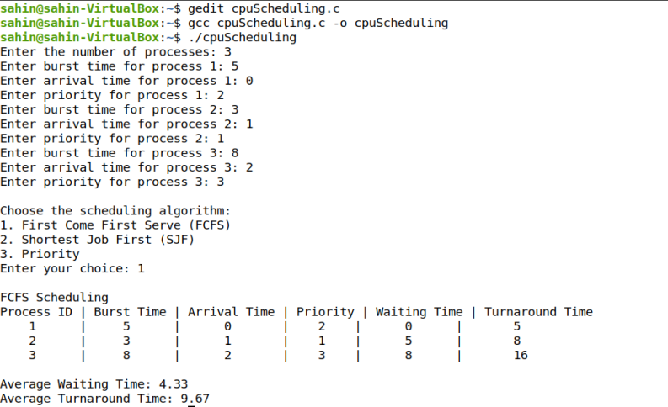

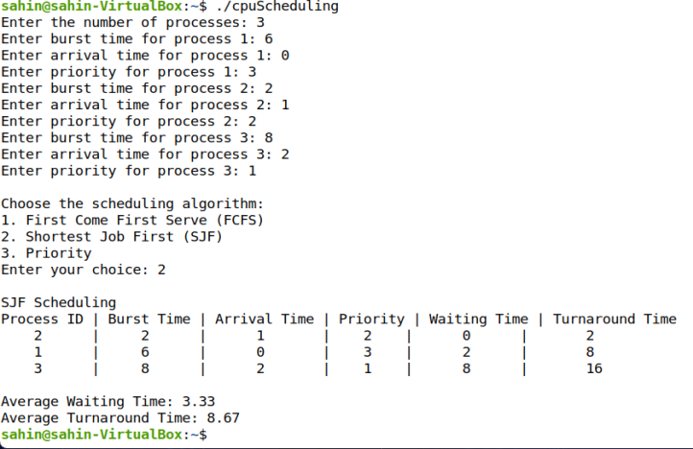 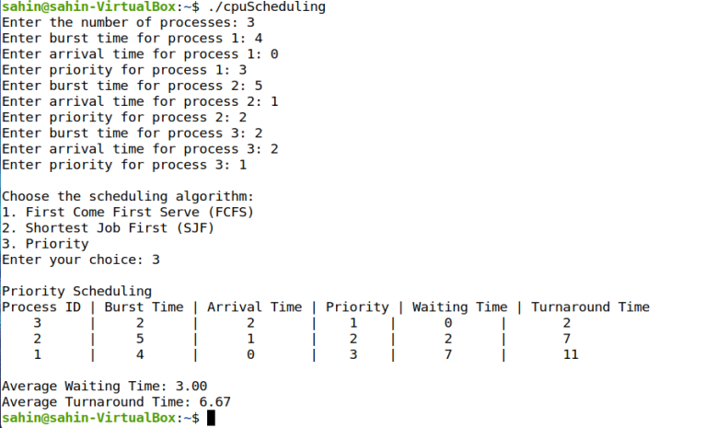

**ASSIGNMENT-4**

**1. Write a C program to simulate a multi-level queue scheduling algorithm considering the following scenario. All the processes in the system are divided into two categories – system processes and user processes. System processes are to be given higher priority than user processes. Use FCFS scheduling for the processes in each queue.**

#include <stdio.h>

#include <stdlib.h>

#define MAX 10

typedef struct {

int id;

int arrival_time;

int burst_time;

} Process;

void sortByArrivalTime(Process queue[], int n) {

for (int i = 0; i < n - 1; i++) {

for (int j = 0; j < n - i - 1; j++) {

if (queue[j].arrival_time > queue[j + 1].arrival_time) {

Process temp = queue[j];

queue[j] = queue[j + 1];

queue[j + 1] = temp;

}}}}

void executeQueue(Process queue[], int n, const char* queueName) {

printf("Executing %s queue (FCFS Scheduling):\n", queueName);

int time = 0;

for (int i = 0; i < n; i++) {

if (time < queue[i].arrival_time) {

time = queue[i].arrival_time;}

printf("Process %d executed from time %d to %d\n", queue[i].id, time, time + queue[i].burst_time);

time += queue[i].burst_time;

}printf("\n");}

int main() {

Process systemQueue[MAX], userQueue[MAX];

int systemCount = 0, userCount = 0, n;

printf("Enter the number of processes: ");

scanf("%d", &n);

for (int i = 0; i < n; i++) {

int type;

Process p;

printf("\nEnter details for Process %d\n", i + 1);

p.id = i + 1;

printf("Enter Arrival Time: ");

scanf("%d", &p.arrival_time);

printf("Enter Burst Time: ");

scanf("%d", &p.burst_time);

printf("Enter Type (0 for System, 1 for User): ");

scanf("%d", &type);

if (type == 0) {

systemQueue[systemCount++] = p;

}

else {

userQueue[userCount++] = p;}}

sortByArrivalTime(systemQueue, systemCount);

sortByArrivalTime(userQueue, userCount);

executeQueue(systemQueue, systemCount, "System");

executeQueue(userQueue, userCount, "User");

return 0;

}

